2015 Itemization Quick Reference
Please note that lines 1115 or 1116 should NOT be used.
Realtor commission paid by buyer – line 701
(Closers will use lines 701,702, and 704 solely for realtor commissions and realtor bonus)
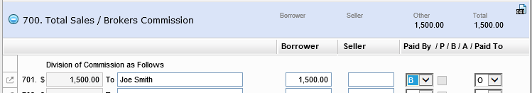
Realtor fees charged to buyer – such as transaction fee, compliance fee, storage fee, etc - any fee line between 1310 and 1320, EXCEPT 1313, which is reserved for completion escrow inspection fees.
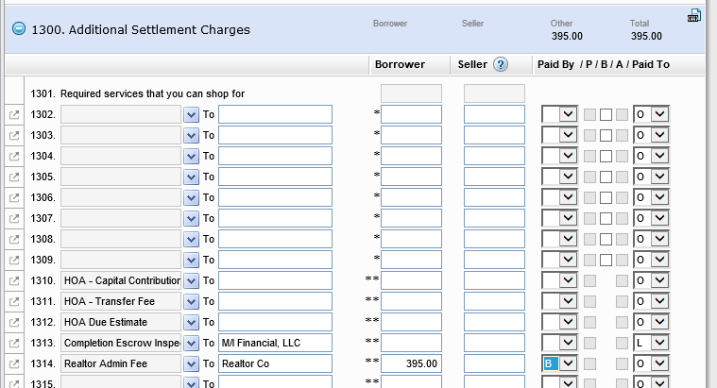
POA recording fee – 1206 – 1208
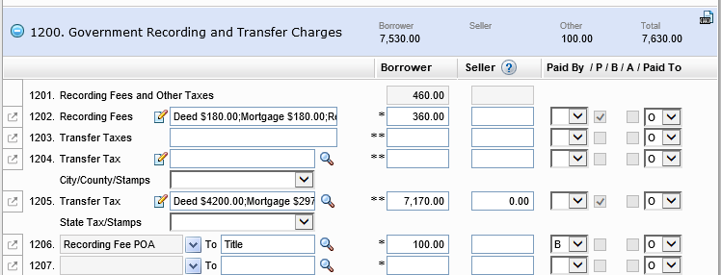

Trust Cert recording fee – 1206 – 1208 (there is not a designated recording fee for trust in the dropdown, “recording fees” or “recording for POA” can be used)
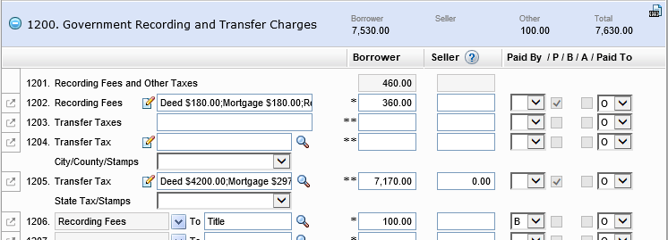
**for recording fees, the fee lines marked with one * have to be used.

For preparation/creation of the POA, Trust Cert, or any Doc Prep that Title/Attorney would do for the buyer, would go on fee line 1102 or 1109 – 1116.
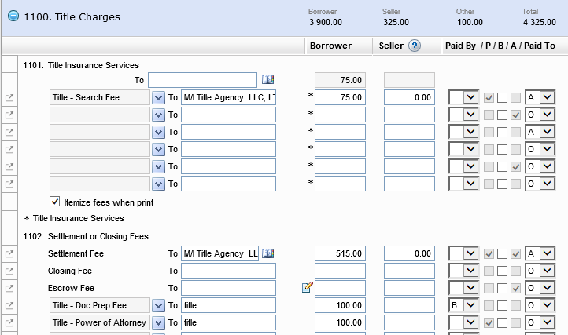

For POA, use the POA prep fee in the drop down.
For trusts, use Title – Doc Prep Fee

Mail away Fee charged by Title/Attorney – fee lines 1109 – 1114 utilize the drop down:
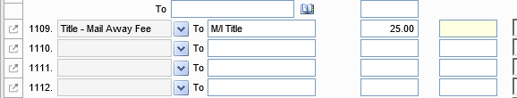

Translation Fee – should be added in the 1300* section so it prints on section C of LE/CD

Mobile Notary Fee - fee lines 1102 or 1109 – 1114
When there is a mobile notary, you need to pick Title-Mobile Notary (do not use notary fee) (If all lines are used up in these places, it could be placed in 1101. It has to be a line within the title fees section that we can marked as “borrower did shop for” so it will print in section C of the LE & CD. )
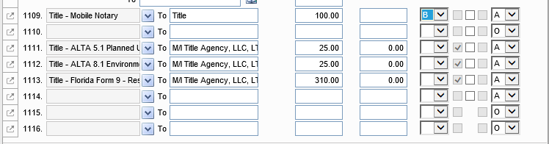
FLORIDA:
CDD Maintenance – lines 1310 – 1320 (EXCEPT 1313).
